Design and configure the Switch network using cisco packet tracer

Aim:
To design and simulate a Local Area Network (LAN) using switches in Cisco Packet Tracer and verify end-to-end connectivity between multiple PCs using the ping command.

Procedure:
- Open Cisco Packet Tracer
- Place Network Devices
  - From End Devices, add required PCs and Laptops to the workspace.
  - From Network Devices → Switches, add two 2950/2960 switches.
- Connect End Devices to Switches
- Connect Switch to Switch
  - Use a Copper Cross-Over cable.
  - Connect FastEthernet port of Switch0 to FastEthernet port of Switch1.
- Assign IP Addresses
  - Click each PC/Laptop → Desktop → IP Configuration.
  - Assign IP addresses in the same network.
  - Example:
    - PC0: 11.10.1.1 / 255.255.255.0
    - PC1: 11.10.1.2 / 255.255.255.0
    - PC2: 11.10.1.3 / 255.255.255.0
  - Leave Default Gateway blank (no router used).
- Check Physical Connections
  - Ensure all cable indicators turn green, showing active links.
- Verify Connectivity
- Observe Results
  - Successful replies indicate proper connectivity.
  - If requests time out:
    - Verify IP addresses
    - Ensure same subnet
    - Check cable types and switch ports

DIAGRAM:
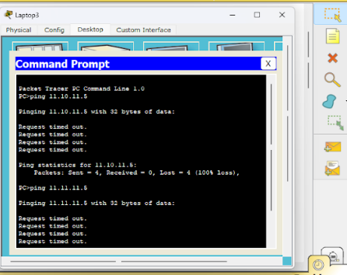
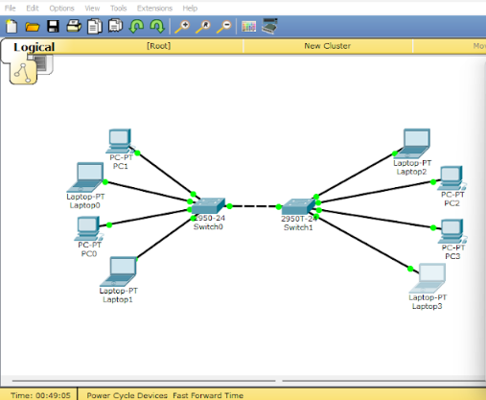

OBSERVATION:

- A LAN was designed using switches in Cisco Packet Tracer.
- Multiple PCs were connected to switches using appropriate cables.
- IP addresses were assigned within the same network.
- No router or default gateway was required.
- Switch-to-switch communication enabled data transfer between PCs.
- Connectivity was tested using the ping command.
- Successful ping replies confirmed proper network connectivity.

RESULT:

The LAN was successfully designed and all connected PCs communicated with each other without errors.

